Power of attorney
(only valid together with a copy of the identity card)

Patient (child):
______________________ ________________________ _________________
Last Name First Name Date of birth

Address

Parent or guardian:
_____________________ ________________________ __________________
Last Name First Name Date of birth

Address


I hereby authorize Mrs./Mr.

_________________________________________________________
(Last name, first name, date of birth)

________________________________________________________
(Address)

for the above-mentioned child, for whom we have joint custody, the appointment for the
Dental treatment under anesthesia
on: _______________________________________________
in sole responsibility and to give all medically necessary measures / declarations as well as the consent to anesthesia also in my name.
If I have any questions about anesthesia, I have the opportunity to inform myself at any time by calling 09602/615353.

_______________________ __________________________________________
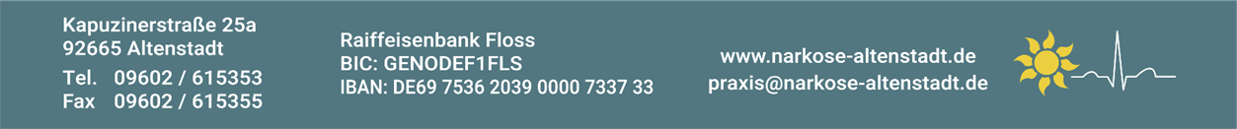
Date Signature of legal guardians

